Bahria University,

Karachi Campus



LAB EXPERIMENT NO.

___12___

LIST OF TASKS

|  |  |
| --- | --- |
| TASK NO | OBJECTIVE |
| 1 | You have to consider a client server chat bot for your project and implement it on asp.net webforms. |
|  |  |

Submitted On:

____18/12/2022____

(Date: DD/MM/YY)

**Task:** You have to consider a client server chat bot for your project and implement it on asp.net webforms.

**Solution:**

**Signal R class:**

using System;

using System.Web;

using Microsoft.AspNet.SignalR;

namespace SignalRChat

{

public class ChatHub : Hub

{

public void Send(string name, string message)

{

// Call the broadcastMessage method to update clients.

Clients.All.broadcastMessage(name, message);

}

}

}

**Owin startup class:**

using Microsoft.Owin;

using Owin;

[assembly: OwinStartup(typeof(SignalRChat.Startup))]

namespace SignalRChat

{

public class Startup

{

public void Configuration(IAppBuilder app)

{

// Any connection or hub wire up and configuration should go here

app.MapSignalR();

}

}

}

**Html page class:**

<!DOCTYPE html>

<html>

<head>

<title>SignalR Simple Chat</title>

<script src="Scripts/jquery.signalR-2.2.2.min.js"></script>

<script src="Scripts/jquery-3.4.1.intellisense.js"></script>

<script src="Scripts/jquery-3.4.1.js"></script>

<script src="Scripts/jquery-3.4.1.min.js"></script>

<script src="Scripts/jquery.signalR-2.2.2.js"></script>

<style type="text/css">

.container {

background-color: #99CCFF;

border: thick solid #808080;

padding: 20px;

margin: 20px;

}

</style>

</head>

<body>

<div class="container">

<input type="text" id="message" />

<input type="button" id="sendmessage" value="Send" />

<input type="hidden" id="displayname" />

<ul id="discussion">

</ul>

</div>

<!--Script references. -->

<!--Reference the jQuery library. -->

<script src="Scripts/jquery-3.1.1.min.js"></script>

<!--Reference the SignalR library. -->

<script src="Scripts/jquery.signalR-2.2.1.min.js"></script>

<!--Reference the autogenerated SignalR hub script. -->

<script src="signalr/hubs"></script>

<!--Add script to update the page and send messages.-->

<script type="text/javascript">$(function () {

// Declare a proxy to reference the hub.

var chat = $.connection.chatHub;

// Create a function that the hub can call to broadcast messages.

chat.client.broadcastMessage = function (name, message) {

// Html encode display name and message.

var encodedName = $('<div />').text(name).html();

var encodedMsg = $('<div />').text(message).html();

// Add the message to the page.

$('#discussion').append('<li><strong>' + encodedName

+ '</strong>:&nbsp;&nbsp;' + encodedMsg + '</li>');

};

// Get the user name and store it to prepend to messages.

$('#displayname').val(prompt('Enter your name:', ''));

// Set initial focus to message input box.

$('#message').focus();

// Start the connection.

$.connection.hub.start().done(function () {

$('#sendmessage').click(function () {

// Call the Send method on the hub.

chat.server.send($('#displayname').val(), $('#message').val());

// Clear text box and reset focus for next comment.

$('#message').val('').focus();

});

});

});</script>

</body>

</html>

**Output:**

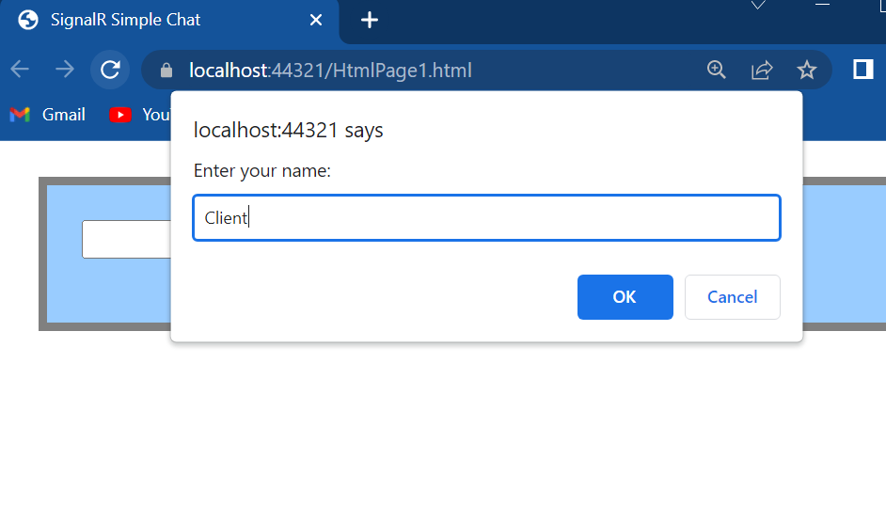

**Client:**

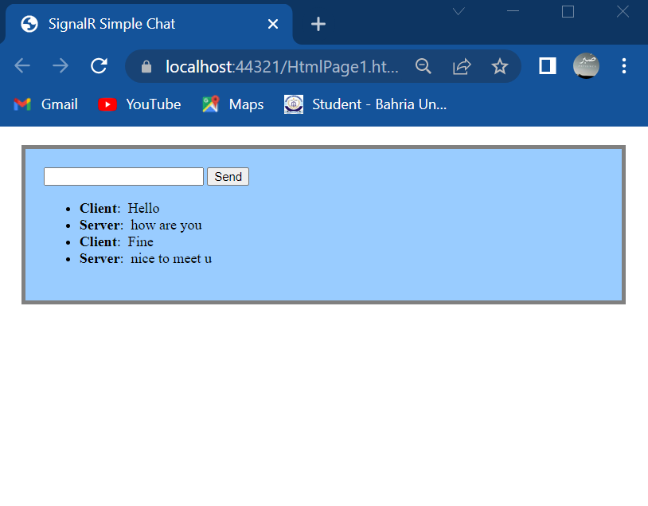

**Server:**

